**Experiment 9**

**Design input forms that validate data (e.g., email, phone**

**number) and display error messages using HTML/CSS,**

**JavaScript (with Validator.js)**

**Aim:**

The aim is to design input forms that validate data, such as email and phone number, and display error messages using HTML/CSS and JavaScript with Validator.js.

**Procedure:**

Step 1: Setting Up the HTML Form

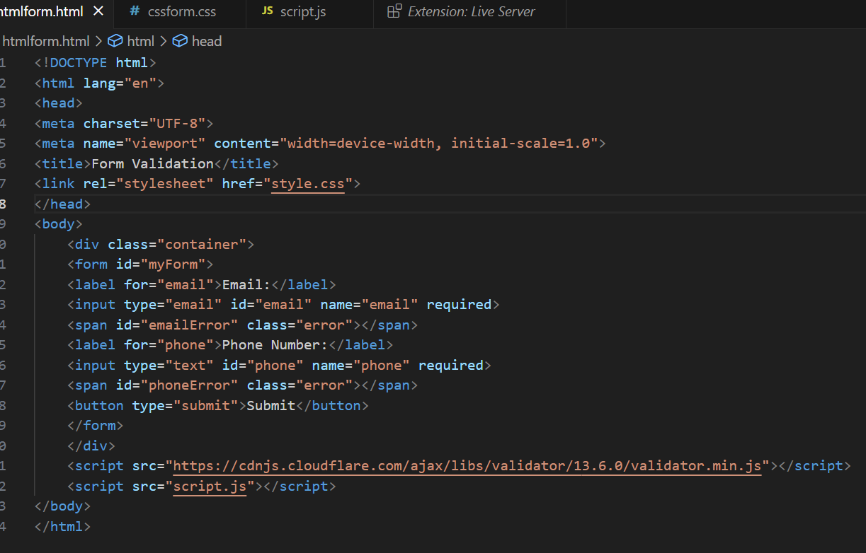

Step 2: Styling the Form with CSS

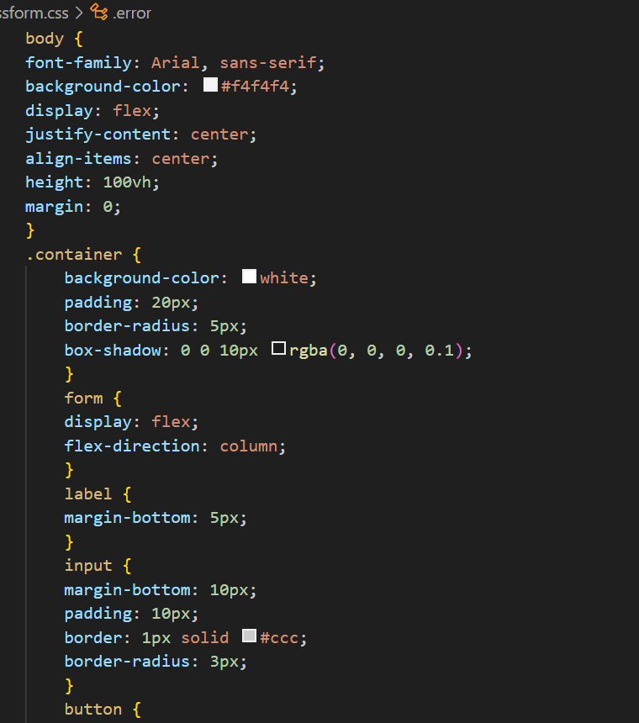

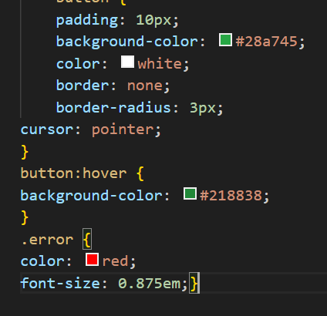

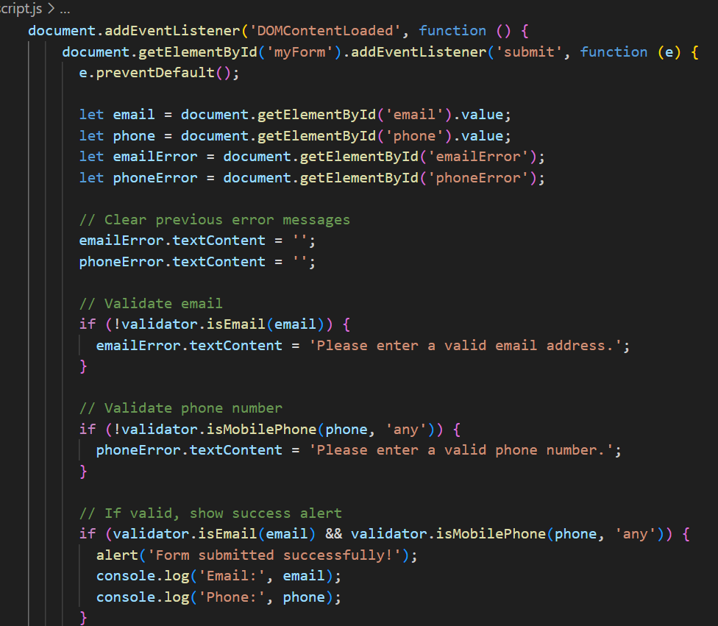Step 3: Adding JavaScript for Validation

Output:

For valid email address

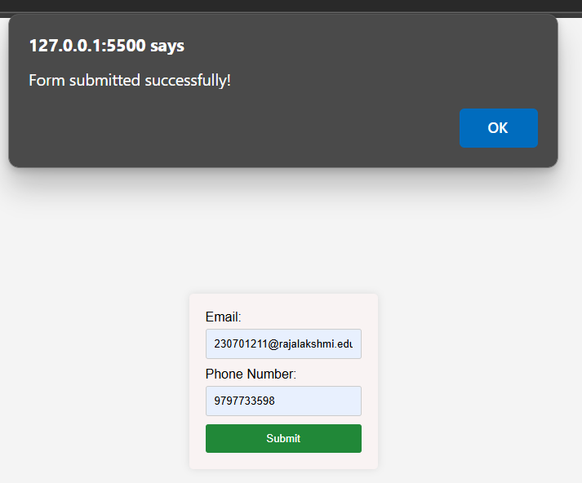

For invalid phone number

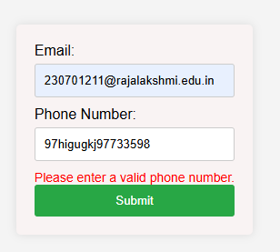

For invalid email address

